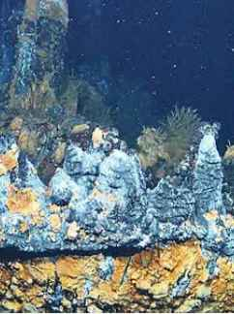**Deep Sea Vents**

Deep-sea vents are hydrothermal vents on the ocean floor, emitting hot, mineral-rich fluids that support unique ecosystems thriving in extreme conditions.

**History**

Discovered in 1977, deep-sea vents are hydrothermal systems on the ocean floor, fostering unique ecosystems fueled by mineral-rich, superheated water.